AEM TASK

I have designed landing pages showcasing travel destinations, featuring a collection of cityscape images accompanied by their respective city names and real-time weather updates .

Sample Outputs :

For Cologne City

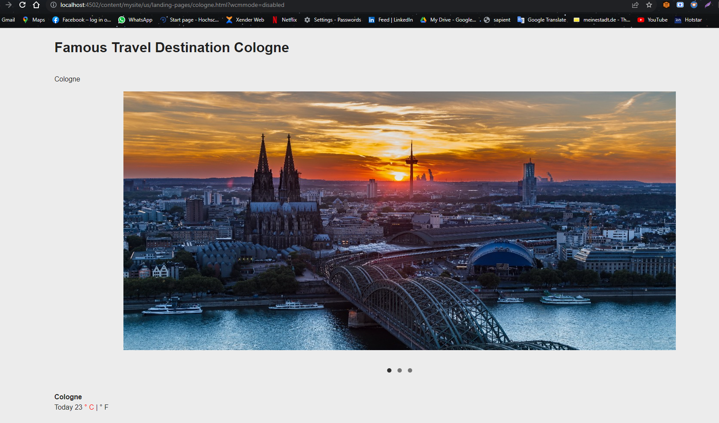

For Dusseldorf City

